AC18Pro PTZ IP Camera Manual
[Part 1: Connect and manage cameras using mobile APP]
Please go google play or Apple store download mobile APP,the name is AC18Pro and install it into your mobile phone
The first time you run the APP, you need to register an account. You can use your email or mobile phone number to register an account, and then use the registered account to log in to the APP.
[1], Configure the camera using WIFI
1. If your camera has WIFI function. Before connecting the power adapter of the camera, please make sure that the LAN port of the camera is not connected to the Ethernet cable (if you have connected it, please disconnect it and press the reset button for 5 seconds to restore the camera to factory settings). After connecting the power, wait 10 seconds.
2. Before using the mobile APP to configure the camera, please connect your mobile phone to your WIFI router via WIFI.
3. Open the APP and click the Add button to add a camera (as shown in Figure 1). And select WIFI (as shown in Figure2), the software will automatically obtain the WIFI of the mobile phone, and please enter the WIFI password (the WIFI connection password of the wireless router). Click Next (as shown in Figure 3)
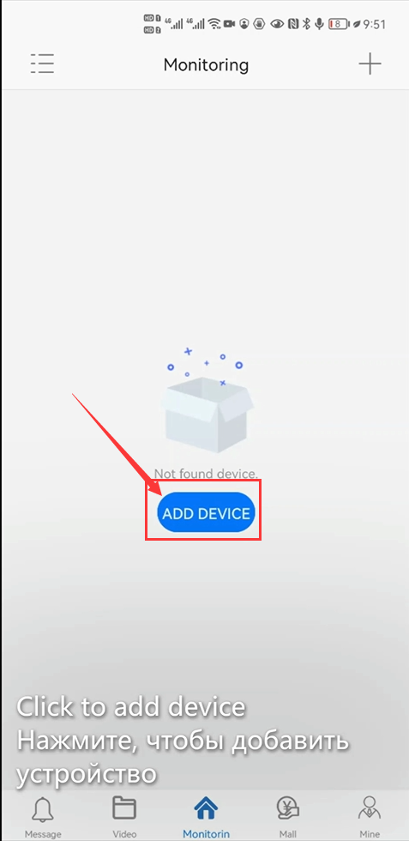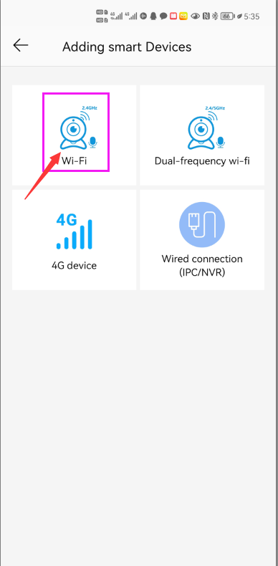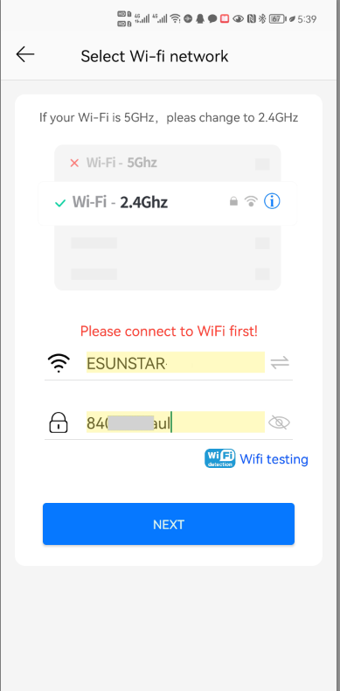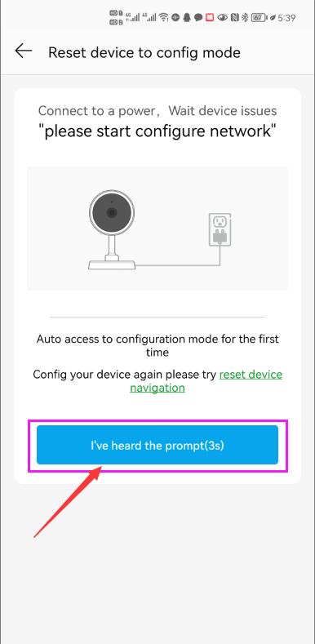
1 2 3 4
After entering the interface of Figure 4, wait for a few seconds, the APP will automatically enter the interface of Figure 5, and the camera will start to match the code through sound waves. When you hear a "di" on the phone, it means that the camera is successfully connected to your wireless router via WIFI (as shown in Figure 6). If your camera does not have a microphone and a speaker at the same time, the sound wave code matching cannot be completed, but you can also add the camera after aligning the QR code on the phone screen with the camera lens. Click the camera on Figure 7, and you will enter the camera's monitoring and management interface (as shown in Figure 8). The camera has been added successfully.
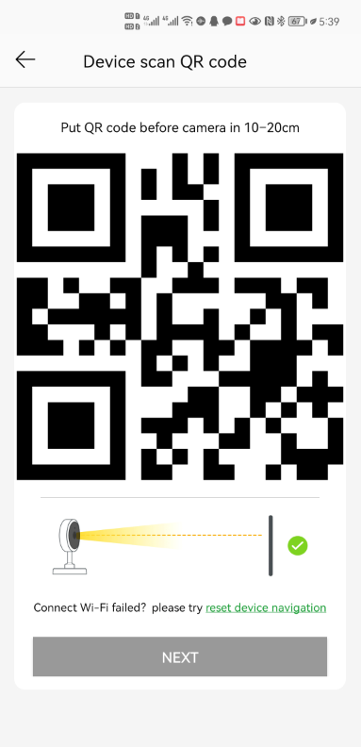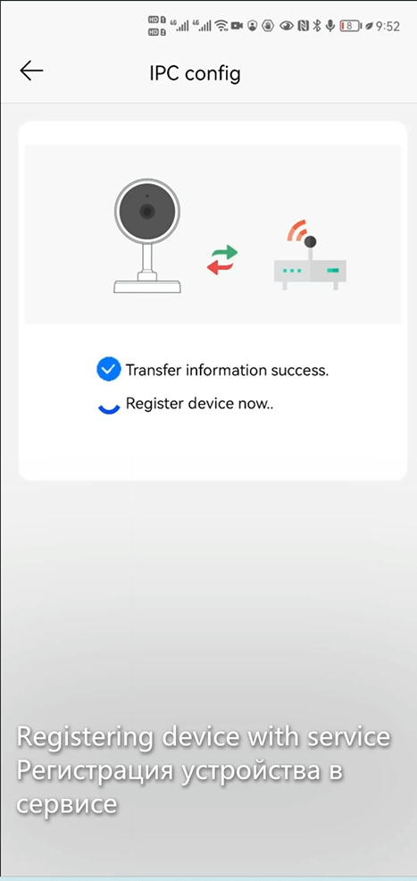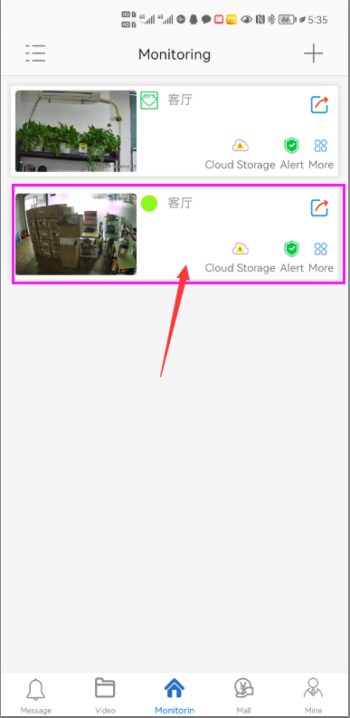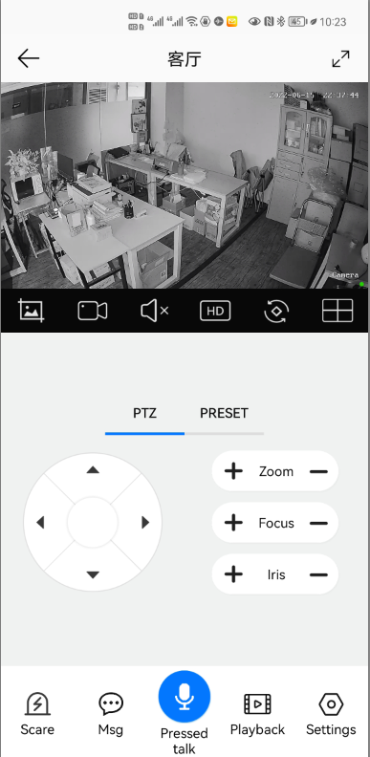
5 6 7 8

[2], Add a camera by scanning a QR code
If your camera does not have WIFI function, please connect the ethernet cable to your switch/router and connect the power adapter. Select "Wired connection camera", as shown in Figure 9, enter the interface of scanning the QR code to add a camera, point the mobile phone at the QR code on the camera body to scan (as shown in Figure 10), after scanning is successful, please provide your Customize a name for the camera, and click "BIND IT" to complete the addition (as shown in Figure 12)
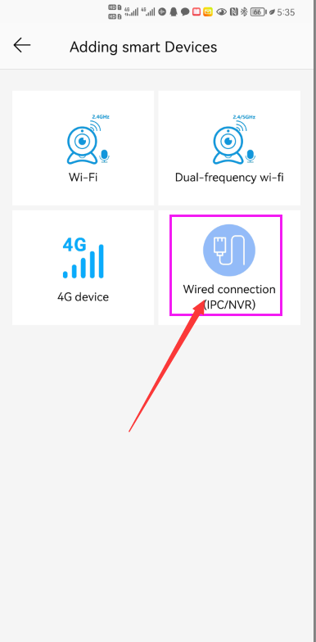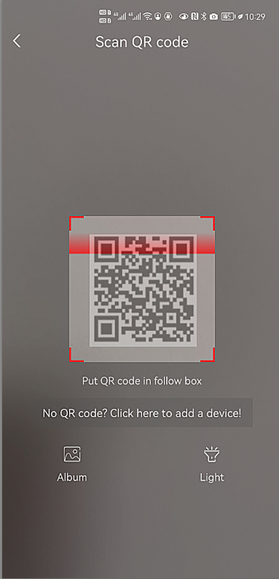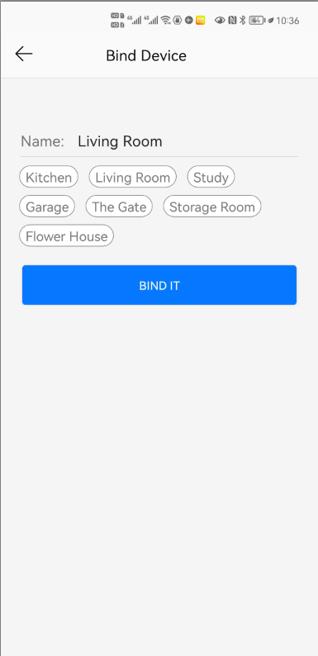
9 10 11 12
[3], Add cameras via LAN connection
If the QR code cannot be found on the camera, you can click "Click here to add a device" to add the camera through the LAN search (as shown in Figure 12), enter the search page, and the APP will automatically search for the camera, as shown in Figure 13 display, and then click the camera to complete the addition.
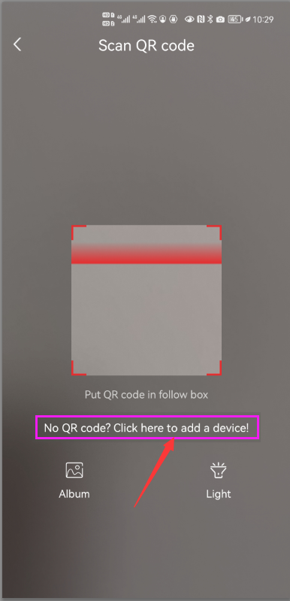
13 14 15 16

1 2 3
Part 2: Add and manage cameras using PC software
[1],Install search tool on your PC
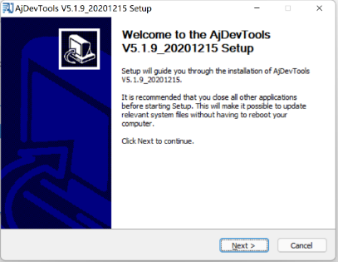
1,Run” AjDevTools_V5.1.9_20201215.exe” and complete the installation
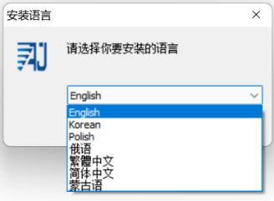
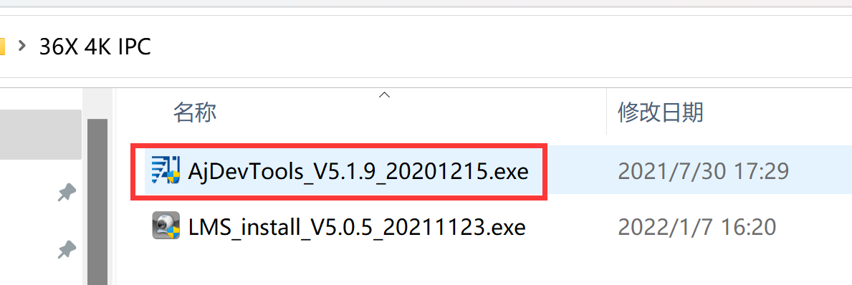

1 2
3
2, Run the software, as shown below（4）
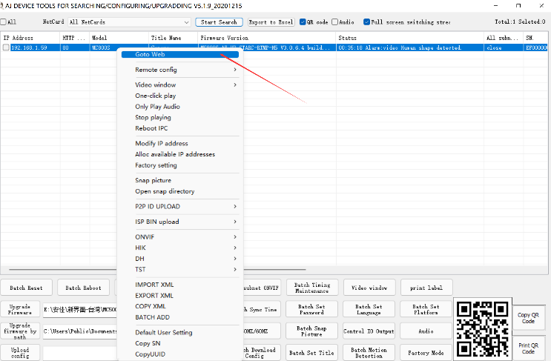
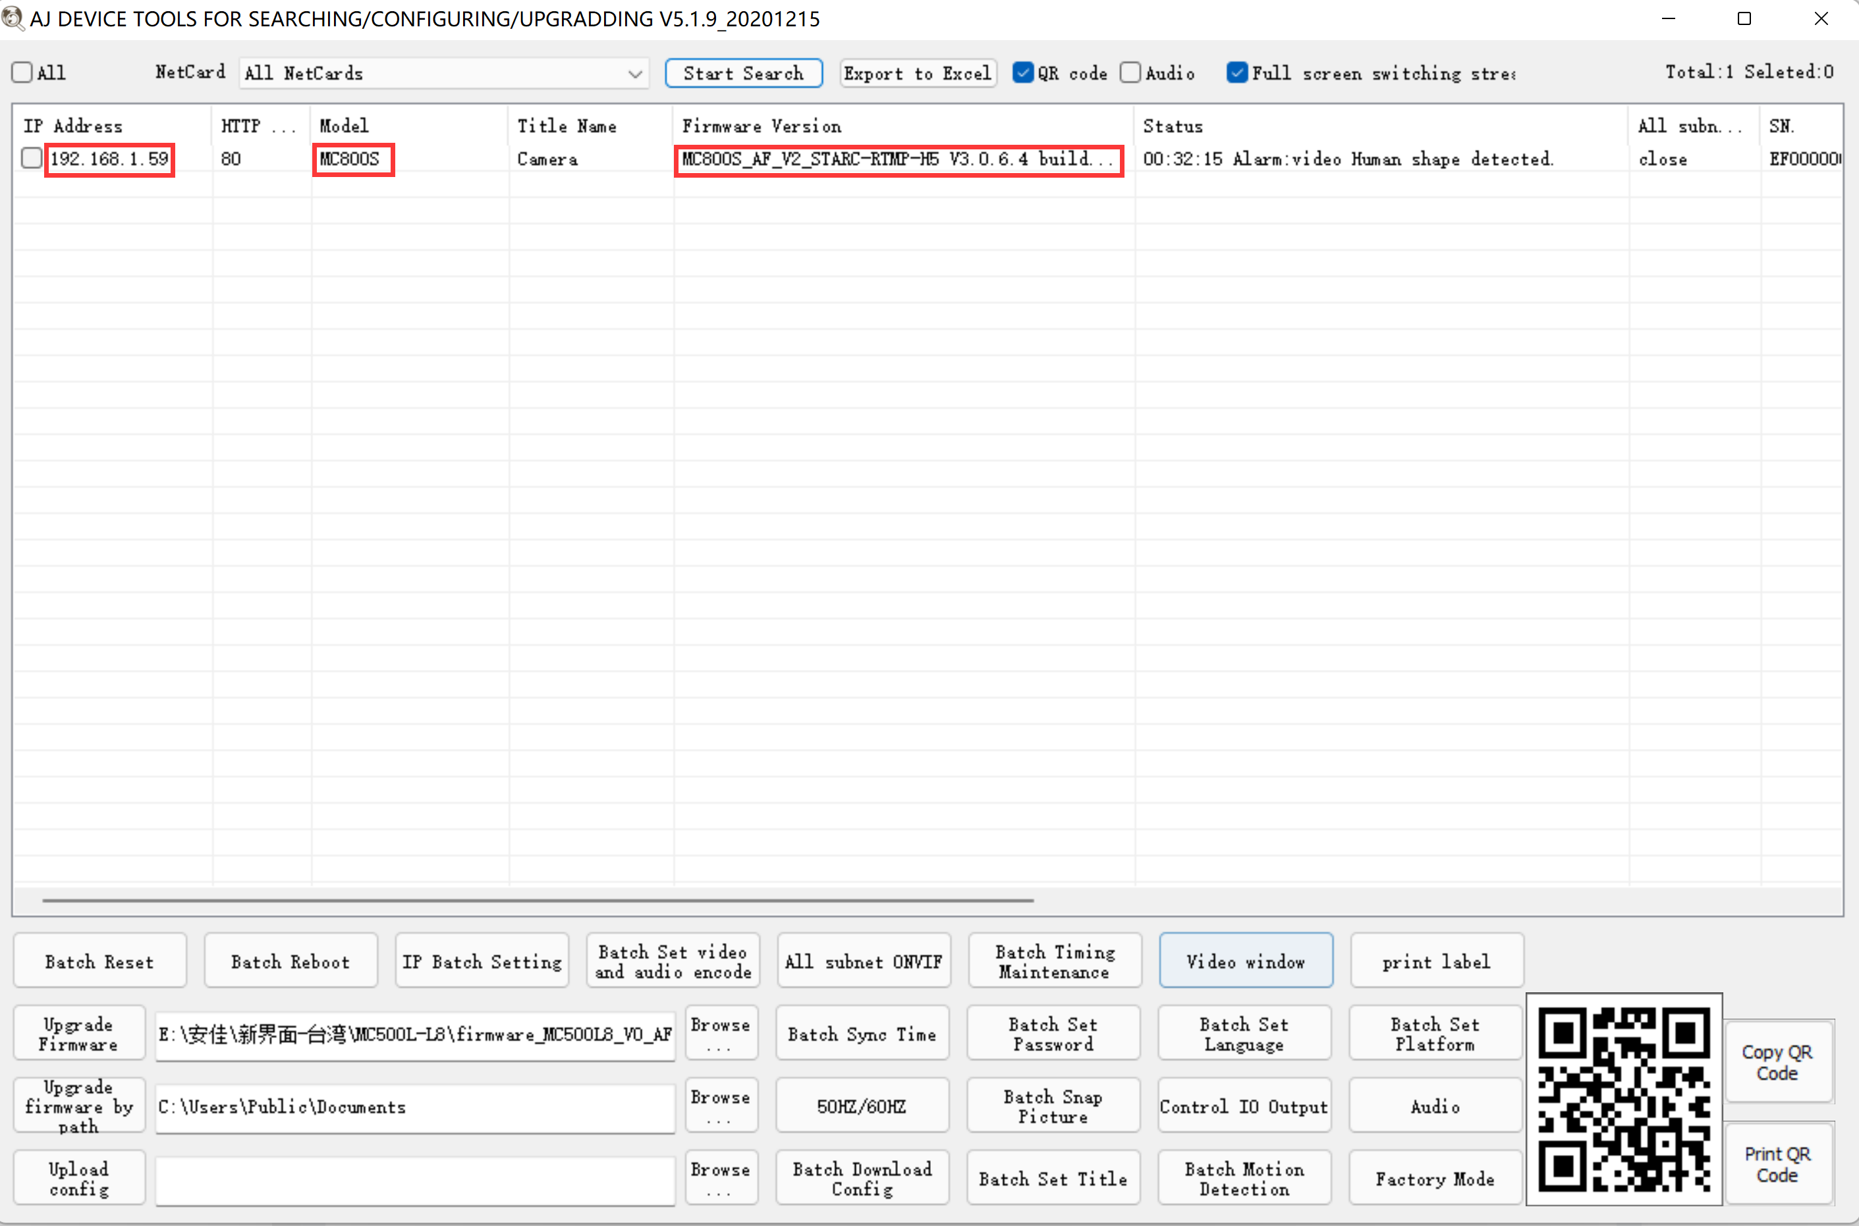
4 5
3, Here you can modify the IP address of the camera, upgrade the firmware and other parameter settings. Right-click on the IP address to open the camera with a browser, as shown in the figure 5.

4,Enter the browser login interface, login user name: admin, password: 123456, as shown in the following figure (if the browser prompts you to download and install the plug-in, please download and install it): Then click login ，as shown in the figure 7
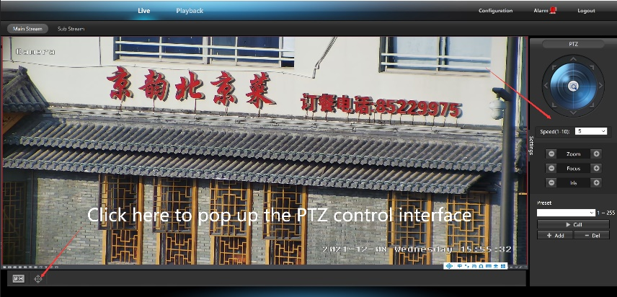
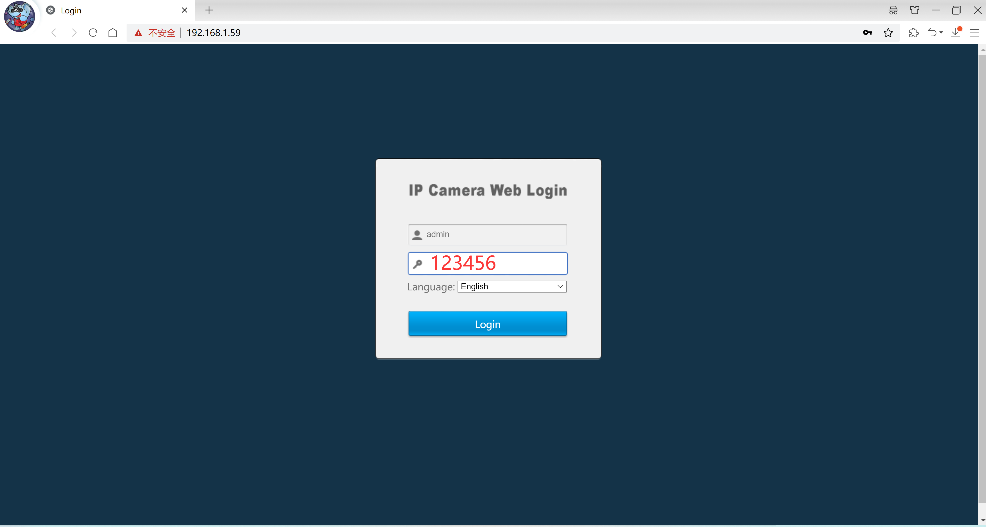
6 7
[2],Use PC software to search and add cameras
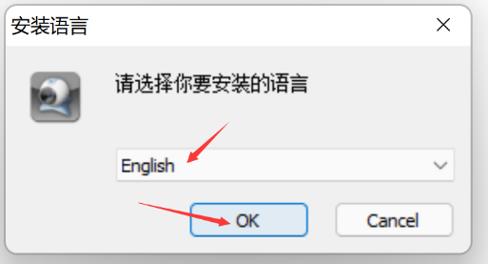
1，Install the LMS computer software.
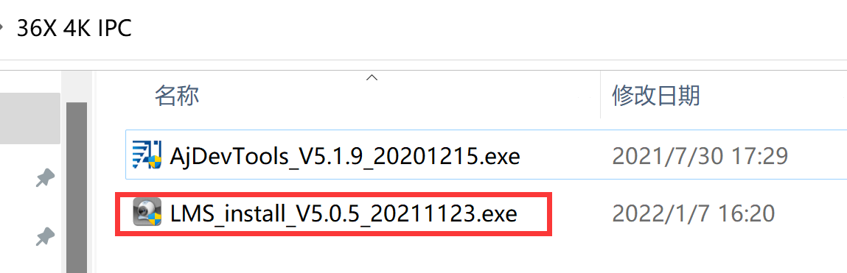
8 9
The software supports English, Simplified Chinese and Traditional Chinese (if you want to support other languages, we can provide you with language packs, you can translate into the language you want, and then we can provide you with software customization)
2，Follow the prompts to complete the software installation
3, Run the LMS software:user:admin,password:123456
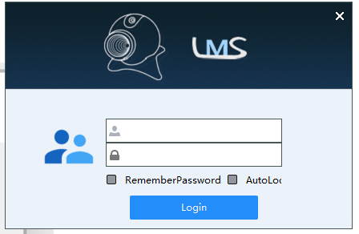
Click LOGIN to log in to the software
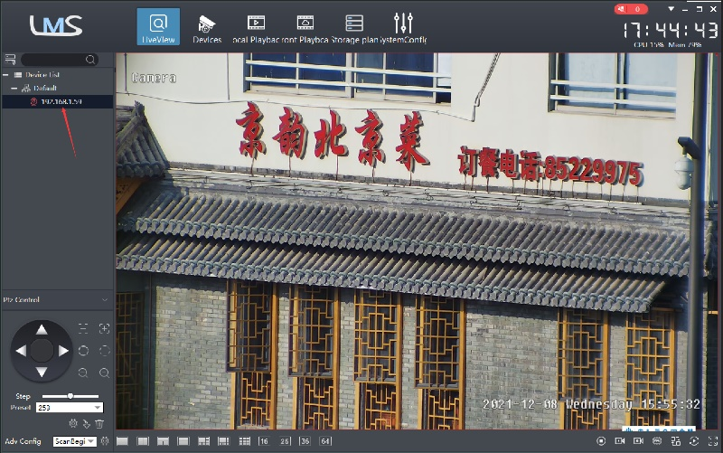
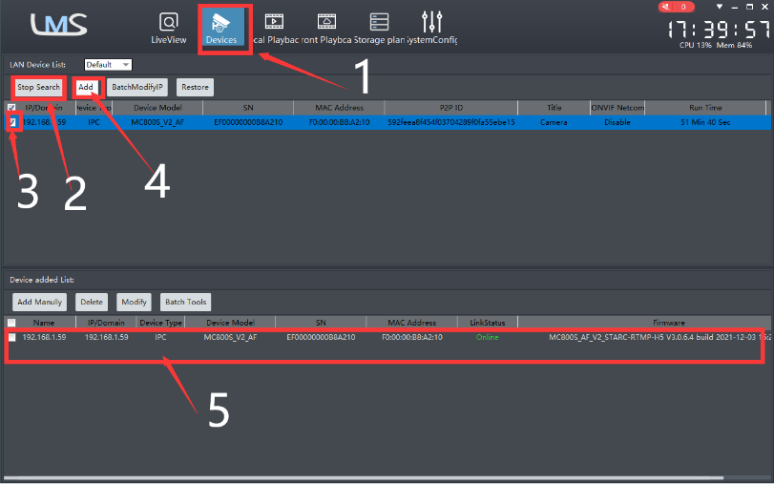

10 11
4. Search and add cameras.Click “Devices>””Start Search”>click“3”>add >successfully added，as shown in the figure 10
Then click” 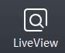” go to Liveview, as shown in the figure 11
Double click on the IP address and the video will automatically appear in the video box on the right.
[3], Preview and control cameras with AC18PRO PC software
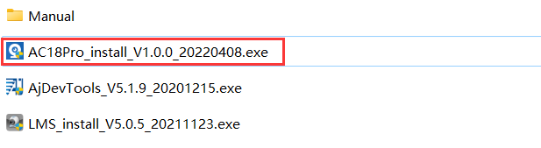
1, Double-click the AC18PRO software in the directory, follow the prompts to complete the installation of the camera, and then run the camera.

2,run and login AC18PRO,
The username and password here are the account you registered for the first time on your mobile phone.
Click login button go to AC18PRO
You will see all the cameras under your account, you can preview the
cameras and view the video playback in this way
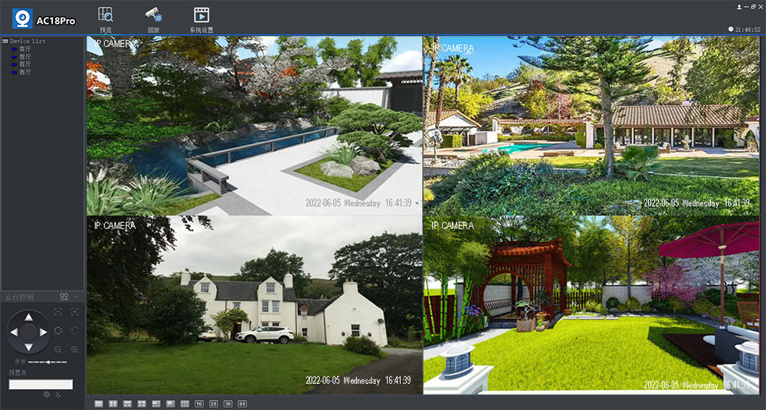
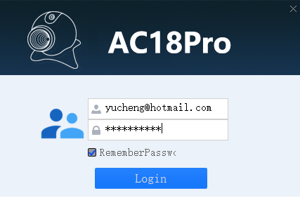

Part 3 【Function Operation and Description】
1.Commnuication settings ：Default PELCO-D/115200)
2.Control the speed dome up ,down and left right rotation
Users can control the speed dome up and down movement by NVR & client soft-ware & mobile app （P2P） & keyboard Joystick’s movement can control the speed dome’s action. when the joystick turn right, the speed dome also turn right. So the speed dome’s movement agree with joystick’s movement.
- Preset settings
Rotate the camera to the position you want, then set this position to “N” preset
[N] +[SET] ,N is preset point, 1-255 number can be optional (But the command Preset isn’t include). Set= set preset
4.Call preset( need set the corresponding preset point) : [N]+[CALL]
N for preset point, 1-255 number can be optional, camera can move to preset point after call, Zoom, focus and aperture lens will automatically change to preset parameters , camera preset display on the monitor.
5,Set auto tracking
- First set a return position: the position of the camera return after the end of the tracking (Home preset position)
Control the camera, rotate the camera to the position you want, and set the 88th preset
. Setting method: [88]+[Set]
- Open/Close tracking (Default Close)
Call 98 for turn on Humanoid tracking, Setting method: [98]+[Call];
Call 99 for Trun on cruise tracking , Setting method: [98]+[Call];( only Suitable for humanoid tracking)
Call 100 for Turn on cruis tracking,Setting modethord: [100]+[Call];( only Suitable for Motion detection tracking)
set 96 for turn off tracking, Setting method: [96]+[Set]
Motion detection tracking sensitivity adjustment :
Set 97 for Low sensitivity, Setting method: [97]+[set];
Set 98 for medium sensitivity, Setting method: [98]+[set];
Set 99 for High sensitivity, Setting method: [99]+[set];
Principle explanation of cruise tracking function:
Before turning on tracking, you need to set the camera's cruise point in advance. A maximum of 16 preset points can be set. These cruise points are the few locations you want to monitor. The camera will cruise back and forth between these locations to find a tracking target. Really made a camera monitors multiple angles of demand. Turn on cruise trackingfunction,The camera will cycle moving through the preset cruise points. When the person is detected, the camera will turn on the tracking. After the tracking is completed, the camera automatically resumes the cruise until the next time the person is detected, the tracking is turned on again
8,Delete all preset point
[93] +[Set] ,Set no.93 preset, Clear the all preset;Setting method :[93]+[Set] .
9,Auto scan(Horizontal rotation)
[120]+[CALL], call No.120 ,the lever of 360 degree clockwise automatic scanning
Modify speed of Auto scan :
[120]+[Set] +[N]+[Set]; (N=1-100; N represents scan speed percentage,default is 10=10 degee/sec)
If you wanto to change speed of auto scan to 50 degee/sec;
Setting method: [120]+[Set] +[50]+[Set]
10, Cruise settings
Before you start cruising, you first need to set some preset position in the cruise path.,Please refer to “ 3.Preset settings”
[115]+[CALL] for Open the first Cruise of 1-16 to scan ；
[116]+[CALL] for Open second Cruise of 17-32 to scan. [117]+[CALL] for Open the third Cruise of 33-48 to scan
Modify the stay time of the Cruise:
[116] +[Set] + [N]+[Set]; (N=1-255; N represents the dwell time at each preset,default is 5 seconds)
If you change the dwell time to 10 seconds.Setting method:[116]+[Set] + [10]+[Set]
Modify speed of the Cruise:
[115] +[Set] + [N]+[Set]; (N=1-100; N represents the dwell time at each preset,default is 10=10 degee/sec)
If you wanto to change speed of Cruise to 50 degee/sec;Setting method: [120]+[Set] +[50]+[Set]

Part 4【Common functions operating Express 】
Function name | Explanation | Preset | Call | Set
Set return position for tracking | The camera will return the position when camera tracking end | 88 |  | √
Close auto tracking | Close auto tracking | 96 |  | √
Open Motion Detection tracking | Track any moving objects, including: animals ,cars and People | 97 | √
Open Humanoid tracking | Only track people | 98 | √
Open cruise tracking | Open auto tracking for People | 99 | √
Open Motion cruise tracking | Open auto tracking for any moving objects | 100 | √
Motion Detection tracking sensitivity adjustment | Set 97 for Low sensitivity, Setting method: [97]+[set]; | 97 |  | √
 | Set 98 for medium sensitivity, Setting method: [97]+[set]; | 98 |  | √
 | Set 99 for High sensitivity, Setting method: [97]+[set]; | 99 |  | √
Humanoid tracking horizontal speed adjustment | 113+set+N+set,N=Percentage of maximum speed, | 113 |  | √
Humanoid tracking vertical speed adjustment | 114+set+N+set,N=Percentage of maximum speed, | 114 |  | √
Motion Detection tracking horizontal speed adjustment | 117+set+N+set,N=Percentage of maximum speed, | 117 |  | √
Motion Detection tracking horizontal speed adjustment | 118+set+N+set,N=Percentage of maximum speed, | 118 |  | √
Dipped beam and high beam switch | The user can arbitrarily set the near light and the remote light to switch position. | 101 | √
Set tracking hold time | 105+call+X+set, X=2-100 seconds | 105 | √
Set tracking zoom value | 102+set+X+set,X=1-50, X= 10 steps
Full IR open | The user can arbitrarily set the position where the near light and the far light are simultaneously turned on. | 102 | √
IR light auto mode | Infrared light is controlled by changes in light brightness | 149 |  | √
IR light Forced on mode | IR light is always on, and the camera stays in night mode. | 150 |  | √
IR light Forced to close | IR light is always off during , and the camera is in day mode | 149 | √
Auto scan(pan)1 | 360 degree clockwise rotation scan | 120 | √
Auto scan(pan)2 | 360 degree counterclockwise rotation scan | 121
Auto scan(pan)3 | 360-degree round-trip scanning | 122
Modify speed of Auto scan | [120]+[Set] +[N]+[Set]; (N=1-100; N represents scan speed percentage,default is 10=10 degee/sec) | 120 |  | √
Open the first cruise | Open the first cruise without Tracking | 115 | √
Open the second cruise | Open the second cruise without Tracking | 116 | √
Open the third cruise | Open the third cruise without Tracking | 117 | √
Set cruise speed | [115] +[Set] + [N]+[Set]; (N=1-100; N represents the dwell time at each preset,default is 10=10 degee/sec) | 115 |  | √
Modify the stay time of the Cruise | [116] +[Set] + [N]+[Set]; (N=1-255; N represents the dwell time at each preset,default is 5 seconds) | 116 |  | √
Left limit | Set Left limit | 110 |  | √
Right limit | Set Right limit | 111 |  | √
Save left-right position | Save left-right position | 112 |  | √
Turn on left - right scan | Turn on left - right scan | 112 | √
Modify the speed limit scan | Modify the speed of right and left limit scan:110+call+N+call, (N=1-100; N represents Cruising speed percentage,default is 10 degee/sec) | 110 | √
Set the Home position | [125]+[Call]+[N]+[Call] ,N=Preset ,default N=1,1th preset position | 125 | √
Open Home position | [124]+[Call] | 124 | √
Close the Home positon | [124]+[set] | 124 |  | √
Set the Home start time | 125+set+N+set N  (N=1-250 ; N represents start time,default N=5= 5 seconds ) | 125 |  | √
Open Lens focal length and speed match | PTZ speed, lens zoom automatic matching is enabled (default is on) | 108 | √
Open ZOOM/Speed automatic matching( default) | ZOOM and rotation speed are automatically matched, the larger the ZOOM, the slower the rotation speed | 108 |  | √
Close ZOOM/Speed automatic matching( default) | ZOOM has nothing to do with rotation speed | 108 | √
Delete all preset point | Delete all preset point | 93 |  | √
pan/tilt correction | Horizontal and vertical self-test | 94 | √
Restore factory settings | 64+call+62+call+62+call | 64 | √

